Answers to Exam Questions

Institutional Affiliation
Professor’s Name
Student Name
Course Name
Date

Final Project Scenario Answers
Part 1: Answers

Create a histogram of price data using Inset Histogram on EXCEL. Label appropriately.

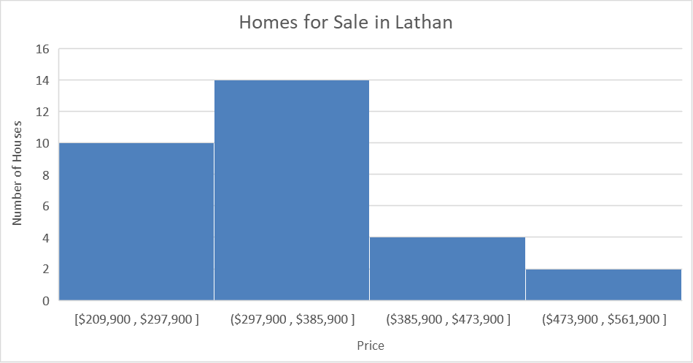

- Describe the shape of the distribution and what the shape tells you about the prices.
The shape of the distribution is skewed to the right. This means that most houses have relatively lower prices while there are few which cost higher.

Use EXCEL to calculate the mean and median price.
Using EXCEL functions average() and median(), the mean price is $337,197.00 while the median price is $317,750.00.

Based on this distribution, is the mean or median a more appropriate measure of center for price? Explain.
Since the distribution is skewed, the median is the more appropriate measure of center for price. Unlike the mean, the median is more resistant to the effects of extreme values.

Calculate the 5-number summary and IQR (by hand).
Arrange the data in ascending order:
209900, 219000, 239900, 259000, 275000, 279699, 282900, 295100, 295500, 296950,
309500, 309900, 314360, 314360, 317750, 317750, 321900, 329744, 331900, 349900,
369900, 369900, 374900, 374900, 389900, 395342, 463055, 470000, 479000, 559000
Minimum
The minimum is the first observation in the arranged data set, so this is
$209,900.
First Quartile
Since 𝑛 = 30, the first quartile is the 8th observation in the arranged data set, so this is $295,100.
Median
Since 𝑛 = 30, the median is the average of the 15th and 16th observations in the arranged data set, so this is calculated as (317750+317750)/2) = 317750. The median is $317,750.00.
Third Quartile
Since 𝑛 = 30, the first quartile is the 23rd observation in the arranged data set, so this is $374,900.
Maximum
The maximum is the last observation in the arranged data set, so this is
$559,000.
IQR
The IQR = Third Quartile = First Quartile = $374,900 - $295,100 = $79,800.
In summary, the IQR is $79,800 and the five-number summary is as follows:

Minimum | = | $209,900
First Quartile | = | $295,100
Median | = | $317,750
Third Quartile | = | $374,900
Maximum | = | $559,000

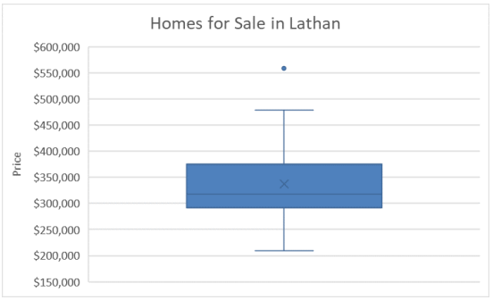

Part 2 Answers
- Scatter Plot:

- The correlation coefficient was calculated using the CORREL function in Excel. According to the resulting value, there is a strong positive correlation between square feet and price of the house (R = 0.79).
- The regression equation can be determined by adding a trendline on the scatter plot or even using the Regression feature in the Data Analysis tab. The equation is presented below:
$$Price=54857.30+127.79*SquareFeet$$

SUMMARY OUTPUT
Regression Statistics
Multiple R | 0.78563046
R Square | 0.61721522
Adjusted R Square | 0.60354433
Standard Error | 49429.6867
Observations | 30
ANOVA
 | df | SS | MS | F | Significance F
Regression | 1 | 1.1E+11 | 1.1E+11 | 45.14815 | 2.7E-07
Residual | 28 | 6.84E+10 | 2.44E+09
Total | 29 | 1.79E+11
 | Coefficients | Standard Error | t Stat | P-value | Lower 95% | Upper 95% | Lower 95.0% | Upper 95.0%
Intercept | 54857.3035 | 42977.79 | 1.276411 | 0.212296 | -33178.7 | 142893.3 | -33178.7 | 142893.3
Square Feet | 127.792141 | 19.01885 | 6.719238 | 2.7E-07 | 88.8338 | 166.7505 | 88.8338 | 166.7505

- According to the regression coefficients, square feet positively affects the house price thus, a unit increase in square feet would result to a 127.79 increase in house price.
- Using the equation from #3, the estimated price of a 2,235 square feet house would be $340,472.7. This estimated price is greater than what the real estate agent suggested by a margin of $35,472.74.
$$Price=54857.30+127.79(2235)$$
$$Price=340,472.70$$
$$Difference=340,472.70-305,000=35,472.74$$
Part 3 Answers
a) Null hypothesis H₀: μ = 305000
Alternative hypothesis: H₁: μ ≠ 305000

b) Assumption: Prices of comparable houses in Latham is normally distributed.

c) The test statistic formula for z score is,
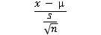
Sample mean x̅ = 337197

Sample standard deviation s = 78503.78

Value of test statistics:
t = (337197-305000)/(78503.78/(SQRT(30))) = 2.2464

d)
P-value = 0.032462
e)

P value is less than the alpha value. (0.032462 < 0.05). Therefore, we reject null hypothesis at 5% significance level.
f)
At 5% significance level, the average price of comparable homes in Latham is different to 305000.
Conclusion
The descriptive statistics indicate that the mean of the houses in Lathan is $317,750. The mean is higher than the $305,000 the agent quoted. According to the regression analysis, the scatter plots and the trend lines are not supporting the price quoted by the real estate agent. The estimated price of a 2,235 square feet house would be $340,472.7. This estimated price is greater than what the real estate agent suggested by a margin of $35,472.74. These means the real estate agent has underquoted the house. From the t-test, at 5% significance level, the average price of comparable homes in Latham is different to 305000. The agent quoted $305,000, a relatively lower price for the house than was the actual price of the house in Lathan with the same or close specifications. These indicates that the real estate agent should have given a better price for the house than the quoted amount. Hence, I should not accept the house to be listed with that amount.

Question 1
a)
Compute a 90% confidence interval for n=36, mean= 2.25, and standard deviation = 0.15.
We compute the Z statistics because the sample is assumed to be approximately normal.
The formulae is X ± Z *s/√n
=2.25 ± 1.645 × 0.15/√36
= 2.25 ± 0.041125
= 2.208875, 2.291125
= (2.208, 2.291)
b)
Conditions for confidence interval
1. The data must be sampled randomly and without replacement from the population.
2. The sample size must be more than the 10% of the population.
c)
We have a 90% confidence that the sample mean for the amount of beverages dispensed by the machine is between 2.208 and 2.291 dl.
d)
A 99% confidence interval would be wider than a 90% confidence interval. 90% is equivalent to 0.041125, while 99% is 0.0644 which is a wider range.
Question 2
a)
Mean = 5.083333

Standard Deviation = 3.476109
b)
Computing a 95% Confidence Interval
We will employ the t-test
= X ± t × s/√n
T-value
1. Degrees of freedom = n-1 = 12-1 = 11 dg
2. Alpha level = (1-0.95)/2 = 0.025
3. t-table for 11 degrees of freedom against 0.025 alpha level is 2.201.
= X ± t × s/√n
= 5.0833 ± 2.201 × 3.476109/√12
= 5.0833 ± 2.2087
= (2.8746, 7.292)
c)
Conditions for confidence interval
1. The sample size is less than 15.
2. The sample is roughly symmetrical, single peak, and has no outliers.
d)
We have a 95% confidence that the employees at Direct Marketing Industry have a mean of between 2.8746 days and 7.292 days 0f the days they are absent from work due to sickness for a period of one year.

